

**Drexel University**

**Electrical and Computer Engineering Dept.**

**Computer Architecture , ECE-C355**

**TITLE: Term Project Report**

**Team Members: Avik Bag, Kunal Malik**

**Instructor: Cem Sahin**

# **Design Principles**

The MIPS instruction set illustrates four underlying principles of hardware design:

1. Simplicity favors regularity.
2. Smaller is faster.
3. Good design demands compromise.
4. Make the common case fast.

 Most Instructions in MIPS has *exactly* three operands. MIPS has 32 32-bit registers, *$v0,...$v31*, a very large number would increase the clock cycle time as reflected by (2) above. The compromise represented by the MIPS design, was to make all the instructions the *same* length, thereby requiring different instruction formats(3).

The MIPS instruction set addresses this principal by making constants part of arithmetic instructions. Furthermore, by loading small constants into the upper 16-bits of a register(4).

# **Part A**

**Mips Code :**



**Machine Code (Hex)**

8d100000

8d110004

12110002

02959820

08000024

02959822

ad130008

Line 1: 0x00000000:0x8d100000 [lw $s0 0($t0) => I(op:35(lw) rs:8(t0) rt:16(s0) immed:0x00000000)]

Line 2: 0x00000004:0x8d110004 [lw $s1 4($t0) => I(op:35(lw) rs:8(t0) rt:17(s1) immed:0x00000004)]

Line 3: 0x00000008:0x12110002 [beq $s0 $s1 L => I(op:4(beq) rs:16(s0) rt:17(s1) immed:0x00000002)]

Line 4: 0x0000000c:0x02959820 [add $s3 $s4 $s5 => R(op:0(add) rs:20(s4) rt:21(s5) rd:19(s3) sh:0 func:32)]

Line 5: 0x00000010:0x08000024 [j EXIT => JFormat(op:2(j) target:0x00000018 >> 2 = 0x00000006)]

Line 6: 0x00000014:0x02959822 [L: sub $s3 $s4 $s5 => R(op:0(sub) rs:20(s4) rt:21(s5) rd:19(s3) sh:0 func:34)]

Line 7: 0x00000018:0xad130008 [EXIT: sw $s3 8($t0) => I(op:43(sw) rs:8(t0) rt:19(s3) immed:0x00000008)]

**Final state of your data memory**



**Challenges Faced**

The implementation of the PC took a while to understand. Getting the PC to increment at every clock rising edge was where the problem occurred. So the way it was solved was by wiring the clock input and checking for every clock rising event.

# **Part B**

**Final state of your data memory**



**Challenges Faced**

The next problem was with the branch statement. The thing about the branch statement is that it brings it to the exact line address in the instruction memory. Now before the start of any cycle, the PC component adds 4 to the incoming PC from the previous cycle. Therefore, to balance it out, the branch address after the entire branch operation is complete, we reduced the value by 4 to ensure that the right line number was reached. Same applied to the implementation of the jump component.

# **Part C**

*C code ( Given)*



**C to Mips**

|  |
| --- |
| 2008000a | addi $t0, $zero, 10 | t0 = 10 = x |
| 20090014 | addi $t1, $zero, 20 | t1 = 20 = y |
| 00005020 | add $t2, $zero, $zero    | t2 = 0 = I |
| 0128c02a | slt $t8 $t1 $t0 | f y < x |
| 1300000f | beq $t8 $zero 15      | if true, exit |
| 01285820 | add $t3, $t1, $t0 | x + y |
| 214d0030 | addi $t5, $t2, 48 | t5 = 48+I |
| 000a7020 | add $t6, $zero,$t2 | base address of A + I |
| 8dcf0000 | lw $t7, 0($t6) | load A |
| 01eb7820 | add $t7, $t7, $t3 | A[i] + x + y |
| adaf0000 | sw $t7, 0($t5) | B[i] = A[i] + x + y |
| 2108ffff | addi $t0, $t0, -1 | x = x - 1 |
| 2129fffd | addi $t1, $t1, -3 | y = y-3 |
| 214a0001 | addi $t2, $t2, 1 | I = i+1 |
| 08000003 | j loop X | |
| **EXIT** |

**Final state of your data memory**

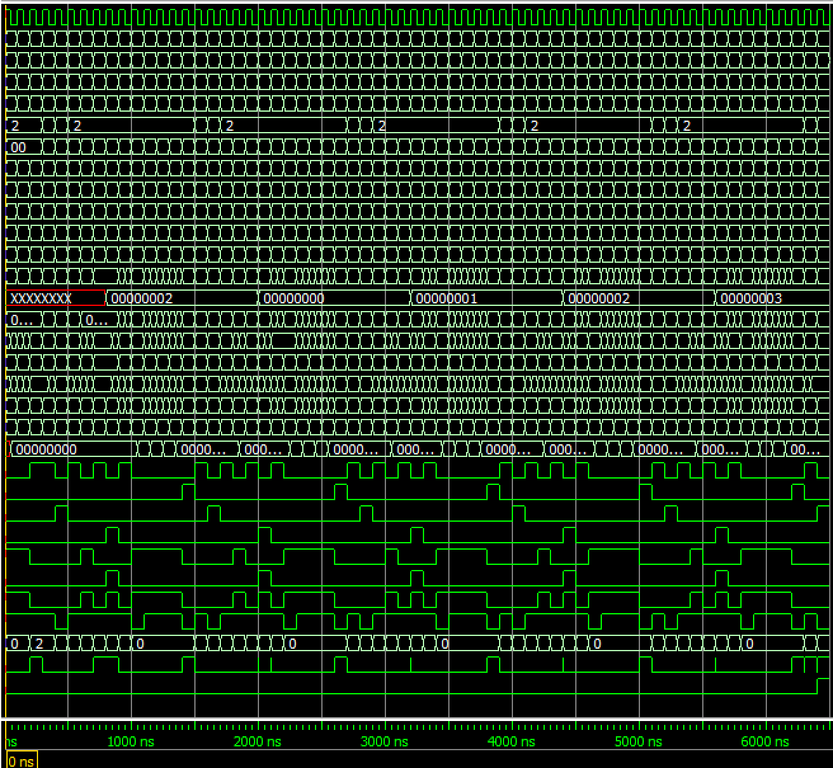

**Total Cycles : 65**

**Challenges Faced**

The problem here was the addi, where we needed to initialize the values. This was also necessary for the incrementation of i which contained the array index. Another issue was trying to fix the slt function so that the desired output was achieved.